**Modelling of magmatic systems underneath the Klyuchevskoy group of volcanoes, Kamchatka**

Introduction

Subduction zones [2_3, 2_5, 2_8, 2_10, 2_11]

Subduction zones are believed to be the most complex tectonic environments on Earth (Winter, ), which occur at convergent plate boundaries. According to plate tectonics, convergent plate boundaries are places where lithospheric plates move towards one another causing earthquakes, volcanism and crustal deformations. During this process the denser and thinner lithospheric plate subducts underneath the lighter and thicker one, which is the case for example in the collision of continental crust and oceanic crust. The down-going of the cool oceanic plate into the asthenosphere causes dehydration of the subducting slab. The influx from the subducting slab is believed to trigger melting and the production of primary magmas, which can be later modified during ascent and differentiation in the crust (2_8_Turner and Langmuir, 2015).

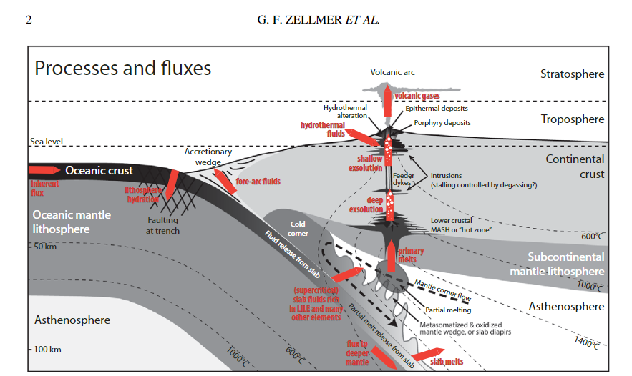

According to G. Sen, Petrology, DOI 10.1007/978-3-642-38800-2_10, the location of the downgoing slab is characterized by the oceanic trench and the Wadati-Benioff zone, which are also considered to be the most seismically active zones with the deepest and strongest earthquakes. The dip of the slab is a very important parameter controlling the volcanism and can vary with depth for a single subduction zone. In order for volcanism to occur, a dip angle greater than about 25° is needed (G. Sen, Petrology, DOI 10.1007/978-3-642-38800-2_10).

As already discussed the downgoing slab brings down ocean water, which enters the crust and the shallow mantle through fractures. This heated water reacts with the surrounding rock and causes metamorphism and the formation of hydrous minerals such as serpentine, zeolite and chlorite. The water-rich material is then carried further down to the asthenosphere, where the pressure and temperatures are high enough to destabilize the hydrous minerals and break them down. As a result denser and less hydrous minerals are formed. The released water in the asthenosphere during this process lowers the melting temperatures of the peridotite which leads to the formation of magma (fluid-fluxed melting) (Sen, 2014).

In general subduction can be described as a very complex process involving different parameters. When it comes to magma, it should be noted that during subduction a wide range of magmas can be produced – from basalt to high-Mg andesite (Sen, 2014). Rocks usually consist of more than one mineral phase and therefore the composition of the rock plays an important role during melting. Since magmas depend on the lowest temperature melting fraction of the rock and the compositions are typically eutectic, the surrounding source rock must be considered. According to Philpotts & Ague, 2009, the upper mantle is composed of peridotite, which main components are olivine and pyroxene. The product after melting these minerals has basaltic composition. This composition can be slightly modified by the presence of other minerals, depending at what depths and pressures the melting takes place. Adding water to this process lowers the temperature of the eutectic resulting in silica richer melts and andesitic composition. Furthermore, if the melting takes place at the base of the lithospheric crust and involves sedimentary and metasedimentary rocks the expected eutectic is between quartz and feldspar and the product rhyolitic magma. An additional requirement for this process to occur at lower crustal temperatures is the presence of water, which is delivered through various metamorphic reactions (Philpotts & Ague, 2009).

The main types of magma are presented in the following table by Philpotts & Ague, 2009 (fig. …..). They have different silica content, which is the parameter controlling the viscosity of the magma. According to Philpotts & Ague, 2009 basalts have the lowest viscosity (~102 Pas), followed by andesite (~103 Pas) and the more viscous rhyolite (>106 Pas). The viscosity of the magma controls also the shape of the intrusive and extrusive igneous bodies. For example, the low viscous basalt can move quickly through fractures and upon extrusion can cover big areas before solidifying. Compared to that high viscous magmas move slower and are unable to travel far before reaching its solid state (Philpotts & Ague, 2009).

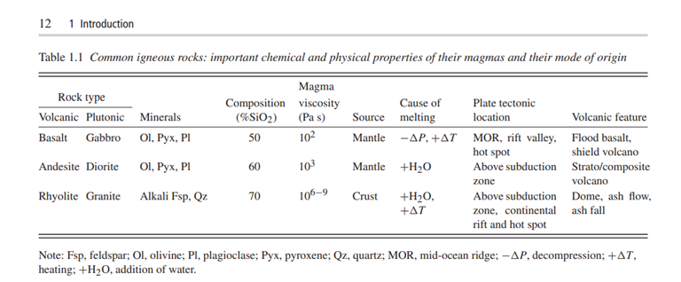

Magmatic systems in the crust [2_1, 2_10]

For a very long period of time, it has been accepted that the volcanoes are fed by a melt-dominated chamber during an eruption. This magma chamber is considered to be long-lived and shallow and to solidify and form igneous bodies. There are numerous sketches in different papers and textbooks supporting this idea, but in the past decades geological, geophysical and petrological observations are delivering new insights about the structure of magmatic systems, which tend to be different than the original idea. In fact, using numerical models it has been shown that the formation of such long-lived magma chambers is very difficult in reality (Cashman et al, 2017).

According to Cashman et al., igneous processes extend through the crust and the magma chamber is located at the top of the magmatic system. This magmatic system is believed to consist of magma chambers connected through channels extending from the lower crust through the middle crust and reach the upper crust. The melt is most probably produced in the greater crustal depths which are then transferred upwards.

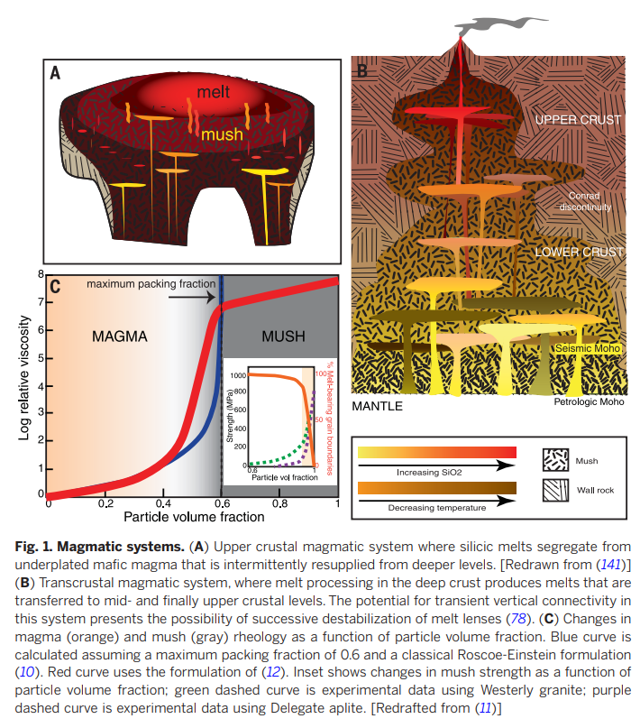It is also important to mention, that the transcrustal magmatic systems do not consist of fully molten rock. They are dominated by crystal mush, which refers to a combination of melt and crystals. According to ......................, the magma can be characterized as a mush, if it contains enough crystals which are touching one another to form a three dimensional network. In this case it can be described as a synonym of partially molten rock and consider them as non-eruptible material, because the rheology is controlled by deformation of the crystalline framework and it depends on the absolute melt fraction (Cashman et al., 2017). Even though that mushes behave more like a solid than like a liquid, they are still capable of moving (…………………..). By contrast to the partially molten material, eruptible magma is described as a suspension of crystals in melt.

Formation of magma chambers and reservoirs (Sparks et al, 2019 – Formation and dynamics of magma reservoirs) [2_12]

According to Sparks et al, 2019 [2_12] a magmatic system has four major physical domains which are related and interacting with each other. These domains include magma, mush with varying melt content and governed by the crystalline framework, super-solidus rocks, and sub-solidus host rocks. The host rock comprises of both older country rock and solidified magmatic products and is usually influenced by heat transfer, fluid influx and stress induced by the magma. Super-solidus rocks are defined by a very low partial melt fraction and are unconnected, whereas in mushes the melt fraction is interconnected and low viscous compared to sub and super-solidus rocks. The magma chamber or magma reservoir is the domain containing the melt and is above the solidus. A magmatic system depends on various external processes such as tectonic processes and convecting meteoric water and this could explain why some magmatic systems extend from the source of the melt in the mantle/deeper crust through the crust reaching the surface to form eruptions, while other magmas solidify in the crust and form plutons [2_12].

Sparks et al., 2019 also focus on the formation of magma chambers and reservoirs which have enough magma volume to cause volcanic eruptions and form plutonic rocks. The authors recognize three main magma chamber formation mechanisms: incremental intrusion, remobilization, melt segregation from a mush.

The mechanism of incremental intrusion involves magma intrusions which form over time and often demonstrate incremental growth caused by repetitive intrusions. However, it is difficult to maintain a chamber or a reservoir in the crust because of heat transfer and the main requirements is to advect more heat into a zone of magma intrusion than it is lost due to conduction [2_12]. Considering this it is important to note that the deeper crust where the host rock is hot enough is a favorable place for the formation of magma chambers. Further key factors which are controlling this process are the input rate and the duration. The idea behind the remobilization concept of magma chamber formation is that the mush, host rock or the super-solidus rock can be transformed into eruptible magma. This can be caused by heat transfer or fluid influx during the emplacement of new fluid rich magma below the mush or the host rock. Magma chambers can also develop by reactive melt segregation in mush, meaning that melt rich layers are formed due to reactive flow through the mush and compaction.

**Kamchatka- Location, geological overview (where, what, how, age)**

Kurile- Kamchatka island- arc system [7, 13, 16, 32, 41]

In order to understand the geological situation of Kamchatka, its location needs to be considered. The Kamchatka peninsula is located in an area dominated by frequent earthquakes and volcanic eruptions, known as the Pacific “Ring of fire”. The "Ring of Fire" extends in a series of arcs from New Zealand, through Indonesia and the Philippines, to Japan and the Kuril Islands, across the Pacific Ocean via the Aleutian Islands, and down the west coast of the Americas (Tanaka, A., 2007 10.1029/172GM08). The tectonics of the Kamchatka peninsula is characterized by the subduction of the Pacific plate, of Cretaceous age beneath the North American plate ([13]). According to Tanaka (2007), the convergence rate of the plates is estimated to be around 80 mm/year.

According to [7], the dynamics and kinematics of a subduction zone correlate with the structure and properties of the hanging wall lithosphere. Gravity measurements, active source seismic data, and receiver function modeling have been used to estimate the crustal thickness along the east coast of Kamchatka and the results indicate a thickness between 30 and 40 km [7]. Furthermore, the geometry and morphology of the subducting Pacific plate may be linked to the kinematics of the plate interface. In the north the downgoing Pacific plate is approximately 87 million years old and its age increases to the south to about 105 million years, which turns it to one of the oldest subducted slabs worldwide [13]. This indicates that there is a relatively consistent lithospheric thickness and buoyancy along the subduction zone [7]. In the northern parts the dip of the downgoing slab changes from 55° to 35°, around 80 km deep underneath Kamchatka.

The properties of the subducted plate are also controlling the geodynamic parameters responsible for the formation of magma and volcanism. One of the most important parameters is the depth of the upper boundary of the slab, because this defines how magma will form in the mantle wedge. Additionally to that, the slope of the slab determines the width of the volcanic arc and whether there will be frontal and rear volcanic zones [32]. Steady-state subduction in Kamchatka and the Kuriles is responsible for the generation of island-arc magmas and volcanism. These magmas were produced in the mantle wedge, where the temperatures are high enough and fluids released from the subducting slab are present to cause melting of water-rich peridotite [32].

* Main tectonic elements of Kamchatka are Sredinny Mountain Chain, Central Kamchatkan Depression, Eastern Kamchatkan Mountain Chain, hills of Kamchatka eastern peninsulas—Shipunsky, Kronotsky, Kamchatsky Mys, Kurile-Kamchatkan deep Trench and Central- and Eastern-Kamchatkan volcanic belts (Irina Nizkous1, Edi Kissling2, Irina Sanina1, Larissa Gontovaya3 and Valeria Levina3, 2007 10.1029/172GM09)

Klyuchevskoy group of volcanoes

Located in the central part of the Kamchatka peninsula in Russia, the Klyuchevskoy Volcanic Group (KVG) consists of 13 active and inactive stratovolcanoes. In some related research publications the Klyuchevskoy Volcanic Group is noted to be a part of the larger Northern Group of Volcanoes (NGV) [9, 10, 42]. The Northern Group of volcanoes lies in the Central Kamchatka Depression, which formation is controversial but one of the hypotheses suggests that it has developed as a rift zone. In this rift zone the subsidence is caused by the back-arc extension of the crust during subduction. The approximate size of this area is 280 x 130 km [10].

The location of the NGV is special because it is situated at the junction of the Kurile-Kamchatka and Aleutian arc, the Emperor Ridge, and the Emperor volcanic area [42], turning the area in one of the largest and most active magmatic provinces in the world. Compared to other volcanic arcs, the subducting Pacific plate is located deeper at around 150km underneath the NGV and the slab is relatively steep [10]. Koulakov et al suggest that the extreme and diverse volcanism in the NGV is caused by the presence of the slab window, which allows the transfer of additional flow from the asthenosphere resulting in an increased temperature below the arc. Another explanation for the intense magmatism in the area could be the high amount of volatiles and melts released by the subduction of the Emperor Ridge, which is a volcanic chain ending with the active Hawaiian hot spot [10].

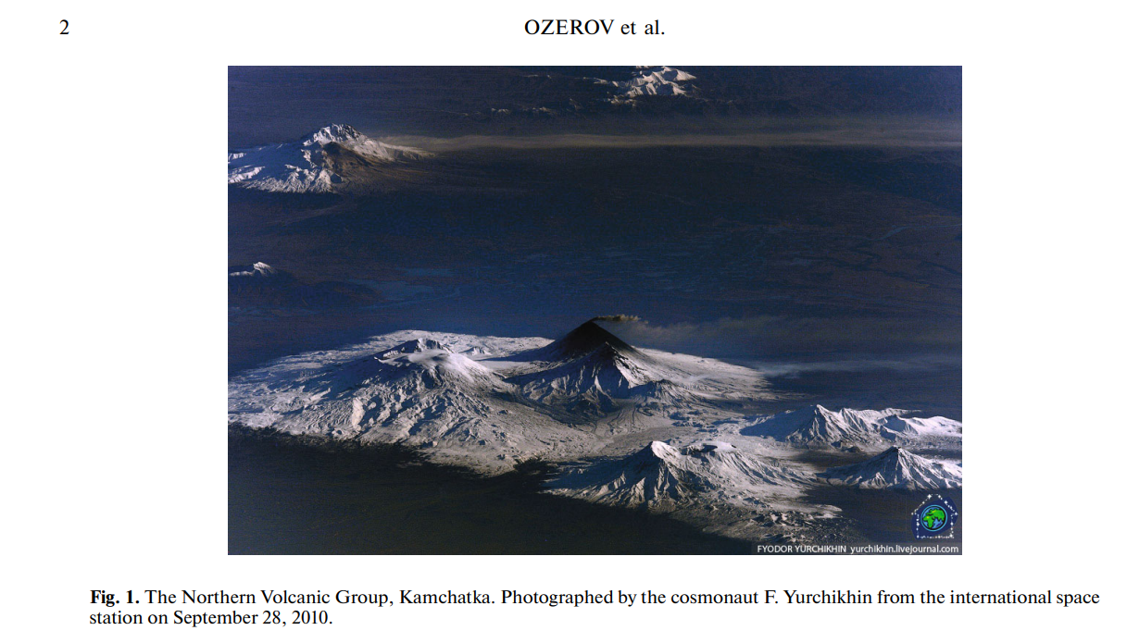

As previously described, the central part of the Northern Group of volcanoes consists of 13 active and extinct volcanoes. The three main active volcanoes of the Klyuchevskoy volcanic group are Klyuchevskoy, Bezymianny and Tolbachik [10]. Green et al suggest that the crustal basement in this area of Kamchatka comprises of cretaceous-paleocene sedimentary and volcanic rocks, caused by the Eocene obduction of the Olyutorsky arc onto northeast Asia.

Klyuchevskoy volcanic group (KVG) is named after its main volcano – Klyuchevskoy, which is the highest active volcano in Eurasia (4750m). It is a stratovolcano with a symmetrical cone and has never experienced a catastrophic explosive eruption or collapse during its 6 000 years of existence [10]. Klyuchevskoy is very active volcano and produces high-Mg basalts with some content of andesibasalts, delivered to the surface as effusive eruptions from the summit crater [10]. The approximate erupted volume is 60 million tons per year [42]. The primitive compositions of the magma suggest that the Klyuchevskoy volcano is fed directly from the mantle source through a vertical channel and Koulakov et al, discuss that the magma source lies at around 30-35 km below the volcano. In their research they have used seismic tomography to detect an anomaly with high Vp/Vs ratio at the corresponding depths [10].

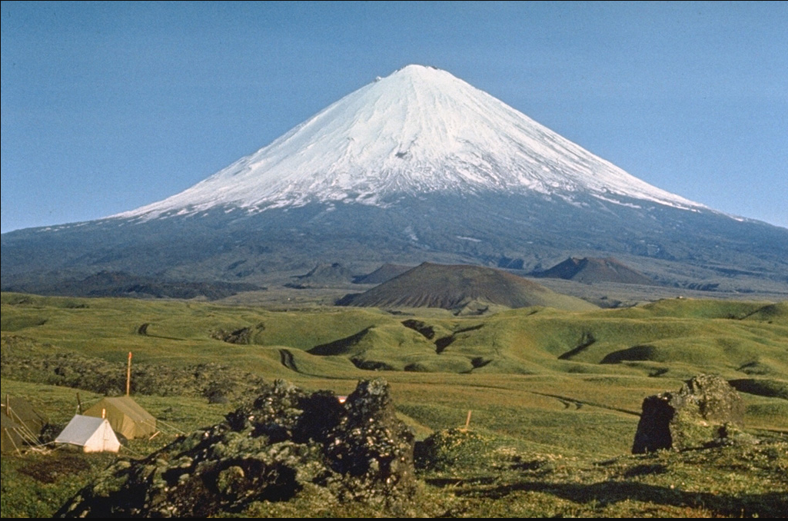

Klyuchevskoy volcano - Photo credit: https://volcano.si.edu/volcano.cfm?vn=300260&vtab=Photos

The second active volcano of the group is the relatively small Bezymianny, formed over the past ~4700 years [10]. It is located in the middle of the KVG [42] and around 10 km away from Klyuchevskoy volcano. Even though both volcanoes lie very close to each other, they have a different eruption styles and magma composition. Its magma is more evolved than Klyuchevskoy’ magmas and has andesitic [42] or medium-K calc-alkaline andesite to dacites and basaltic andesites [10]. The volcano has experienced several catastrophic eruptions, causing sector collapses and partial edifice destruction.

**State of the art – Klyuchevskoy group of volcanoes [1, 22, 23, 20, 18, 25, 28, 31]**

Shape of the slab beneath the Northern group of volcanoes and crustal structures beneath the Klyuchevskoy group of volcanoes according to Koulakov, 2021 [20]

Research on the Klyuchevskoy group of volcanoes has focused on understanding the processes that drive volcanic activity, including the magma dynamics and eruption mechanisms. Different studies have also investigated the geochemistry of the volcanic rocks, as well as the potential hazards associated with future eruptions. Some research has also focused on the impact of volcanic activity on the surrounding environment, including the effects on vegetation, soil, and water resources.

Very characteristic for the KVG and its 13 active and dormant volcanoes are the broad compositional range and eruption styles. In order to gain insight into this diverse magmatic system, it is crucial to conduct a detailed research of the structures at different levels of the mantle and the crust. The area around the KVG has been well investigated and there is enough seismic tomography data to conclude what are the major structures [20].

When considering subduction zones and subduction related magmatism it is worth noting the shape of the subducting slab which has been the main subject of numerous regional and global seismic tomography studies. Several body-wave tomography models deliver important information about the subducted Pacific slab beneath Kamchatka (Gorbatov et al., 2001; Jiang et al., 2009; Koulakov et al., 2011b). Koulakov et al., describe linear high-velocity anomalies (the Aleutian and Kamchatka segments) which are in a good agreement with the earthquake locations in the Benioff zone. Furthermore, they discuss that to the north of Shiveluch volcano, the slab ends which is interpreted as a slab window between Kamchatka and Aleutian segments. Another study using surface-wave tomography suggests similar results (Levin et al. 2002, 2005) [20].

The crustal structures beneath KGV have been well studied by various research groups. Seismic tomography data shows seismic heterogeneities beneath the Klyuchevskoy volcano [20]. According to Koulakov, 2021 (after Koulakov et al., 2011a) the vp/vs ratio gives insights into the potential magma reservoirs. He argues that the magma is accumulated at three different levels: at the bottom of the crust, in the middle crust, and in the upper crust. Beneath the Klyuchevskoy volcano the data reveals an anomaly with relatively high vp/vs ratio and concentrated earthquake activity at around 27-33 km depth, which could be interpreted as an existence of deep magma chamber. Additional to that, the earthquake data can be tracked vertically upwards following a line pattern. Relaying on these observations the author proposes a model, where the deep crustal magma chamber is connected vertically to the surface through a narrow channel, feeding directly the Klyuchevskoy volcano. Furthermore, he describes a strong seismic activity at around 5-8 km depth and shifting from high to lower vp/vs values, which could be an indicator of ongoing degassing triggering magma movement trough the channel up to the surface.

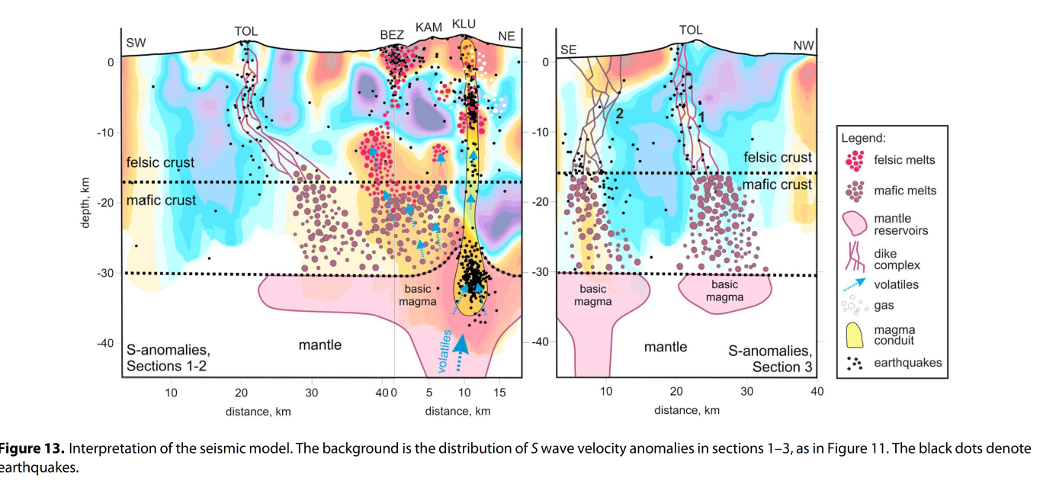The summit area of the Bezymianny volcano shows very high vp/vs ratio as well and this can be explained by the presence of porous and fluid saturated igneous rocks. At around 2 km depth below the surface Koulakov, 2021 describes an area with high vp and low vs values, resulting in a high vp/vs ratio indicating a possible magma chamber containing more primitive and water rich melts. Another low velocity zone with high vp/vs ratio at around 10-15km depth has been presented by Koulakov et al., 2017a [14]. They propose that his volcano is being fed directly by the deep magma chamber which is also supplying the Klyuchevskoy volcano with basic melts. Moreover, they contend that the mantle-derived melts, which are basic and rich in volatiles, ascend in the form of diapirs as they are less dense than the surrounding rocks of the lower crust. Conversely, the upper crust has a felsic composition and lower density, which hinders the diapirs from rising further up due to their lower buoyancy. This is the reason why they believe that this material accumulates at the midcrustal magma chamber [14], where it can undergo other processes and cause volcanic activity.

Geochemical data and interpretations [27]

The Klyuchevskoy volcanic group in Kamchatka produces magmas with a wide variety of chemical compositions over relatively small areas. Klyuchevskoy and Bezymianny volcano are only around 9 km apart from each other and geochemical studies show that they erupt different material, ranging from high-Mg basalts to dacites. The compositional diversity within small spatial scales in volcanic arcs can be explained as a result of different processes in the crust such as magma mixing, fractional crystallization, assimilation, or source heterogeneity [27]. Magma differentiation can be also a possible reason for the production of a wide variety of rock compositions, because magma is usually formed by partial melting consists of liquid saturated in minerals present at the eutectic and grains of these minerals. During transport or solidification the liquid and the solids may separate and produce rocks different than the original magma [**2_3_Principles of igneous and metamorphic petrology**].

According to [27] Klyuchevskoy volcano erupts the highest amount of mafic arc magmas worldwide with compositions ranging from Mg-basalt to high- Al basaltic andesite. It has different eruption syles including vulcanian, strombolian, lava fountaining and lava flows, which could last for weeks or even years. The erupted material from the Bezymianny volcano is mostly andesitic in composition. In the past (1956) it has experienced catastrophic blast eruption and after the 70s its typical volcanic activity is represented by dome growth and collapse resulting in ash flows, sub-plinian eruptions and lahars. The volcano erupts on average once or twice per year. Even though the volcanoes have different eruption regimes and compositions, geochemical analysis show that they present common O, Sr, Pb and Nd isotopic characteristics [27] meaning that they share the same parental magma. Furthermore, [27] argue that Bezymianny magmas are further evolving as a result of closed-system fractionation in mid-crustal reservoirs. Dobretsov et al., 2015 [1] also describe the interaction between both volcanoes relying on major- and trace element compositions. This study suggests that SiO2 and K2O contents are progressively decreasing in Bezymianny lavas and thus approaching the chemical composition of Klyuchevskoy [1].

As previously discussed, Bezymianny volcano’s more recent compositions are basaltic andesites and andesites containing between 56.6 and 60.2 wt% SiO2, 4.53-4.97 wt% alkali (Na2O + K2O). The erupted material from Klyuchevskoy has been also measured and has silica content between 53.8 and 54.6 wt%, MgO around 8.4 wt% and alkali between 4.15 and 4.69 wt%.

Data and model setup

In order to create an accurate model setup representing the geodynamical situation in the Klyuchevskoy Group of volcanoes different data has to be taken into account. The model comprises of topography, earthquake and tomography data. The 3D topography surface is generated using a Julia package for GMT

-topography data

-Earthquake data

-tomography data

-Geochemical data (major elements)/ TAS diagram and data with wt% -> **take from [1]**

**-**eruption volume data

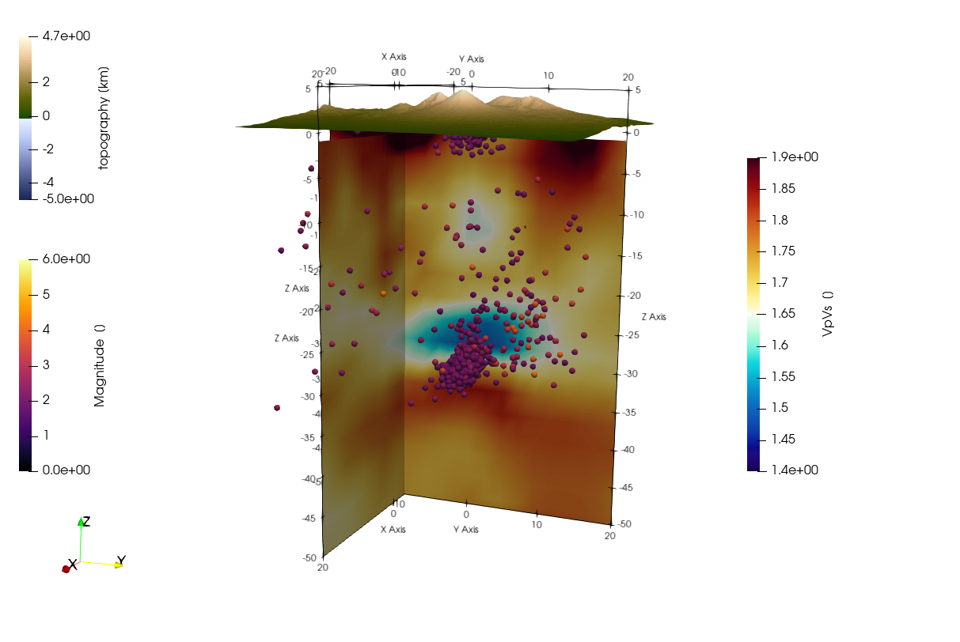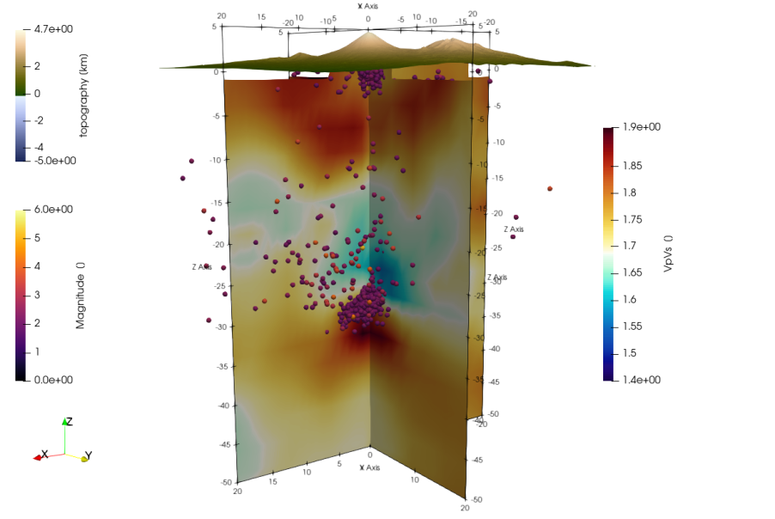

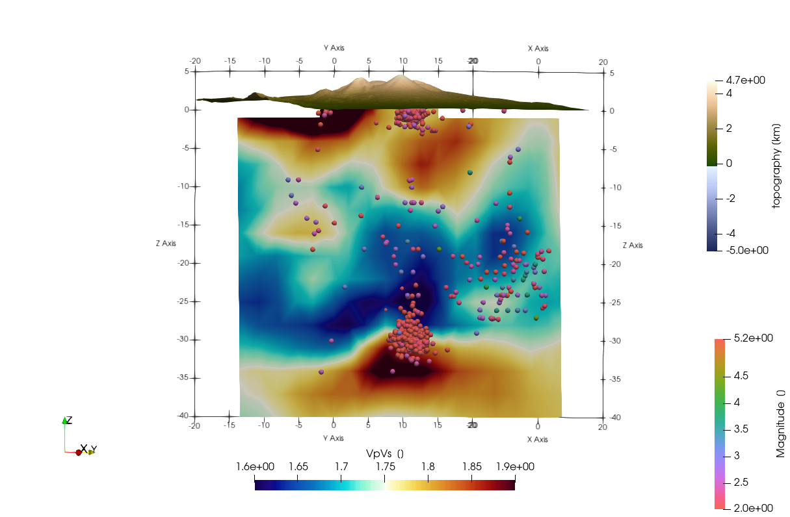Distribution of the vp/vs ratio and earthquake data beneath a) Klyuchevskoy and b) Bezymianny. The seismic data was provided by Koulakov.

Distribution of the vp/vs ratio and earthquake data beneath both volcanoes. The seismic data was provided by Koulakov.

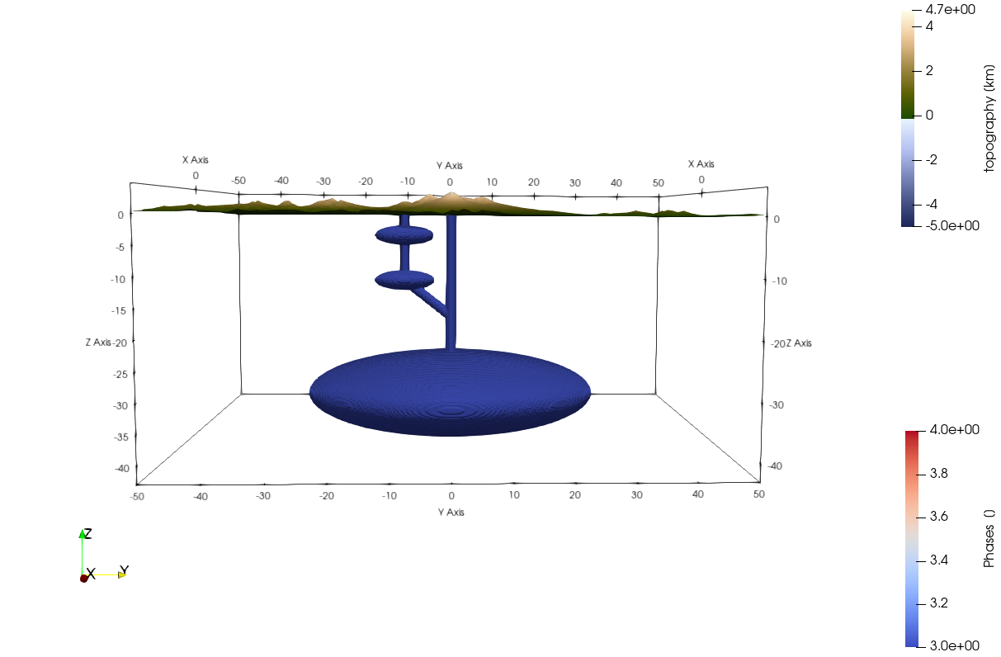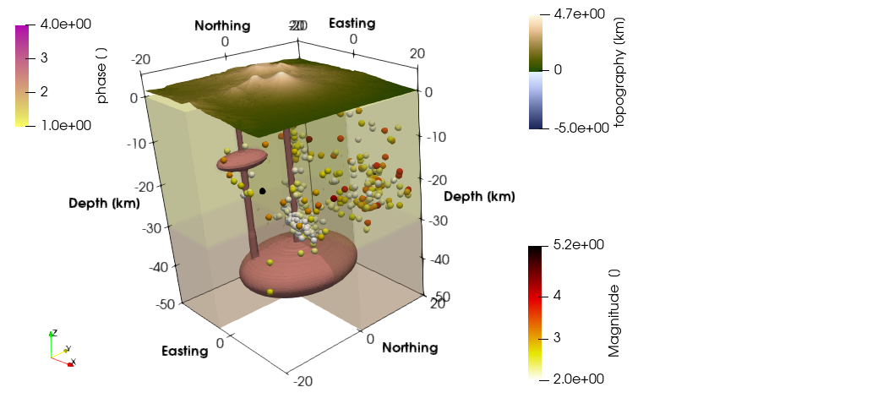

Results

On the rheology of magma: For magma, rheology is controlled principally by composition, dissolved H2O content and temperature of the (usually silicate) melt phase and the volumetric proportions and physical properties (size, shape and surface tension in the case of volatiles) of suspended crystals and bubbles. Melt viscosities typically vary from less than 1 Pas to 10^6 Pas. [directly from 2_12]

References

Sen, G. (2014). Subduction Zone Magmas. In: Petrology. Springer, Berlin, Heidelberg. <https://doi.org/10.1007/978-3-642-38800-2_10>

Philpotts & Ague, 2009. Principles of Igneous and Metamorphic Petrology Anthony Philpotts (Yale University, Connecticut)

[20] Gorbatov, A., Fukao, Y., Widiyantoro, S., Gordeev, E., 2001. Seismic evidence for a mantle plume oceanwards of the Kamchatka— Aleutian trench junction. Geophys. J. Int. 146 (2), 282–288, doi: 10.1046/j.0956-540x.2001.01439.x.

[20] Jiang, G., Zhao, D., Zhang, G., 2009. Seismic tomography of the Pacific slab edge under Kamchatka. Tectonophysics 465 (1), 190–203, doi: 10.1016/j.tecto.2008.11.019.

[20] Koulakov, I., Gordeev, E.I., Dobretsov, N.L., Vernikovsky, V.A., Senyukov, S., Jakovlev, A., 2011a. Feeding volcanoes of the Kluchevskoy group from the results of local earthquake tomography. Geophys. Res. Lett. 38 (9), L09305, doi: 10.1029/2011GL046957.

[20] Koulakov, I.Yu., Dobretsov, N.L., Bushenkova, N.A., Yakovlev, A.V., 2011b. Slab shape in subduction zones beneath the Kurile–Kamchatka and Aleutian arcs based on regional tomography results. Russ. Geol. Geophys. 52 (6), 650–667, doi: 10.1016/j.rgg.2011.05.008.

[20] Levin, V., Shapiro, N., Park, J., Ritzwoller, M., 2002. Seismic evidence for catastrophic slab loss beneath Kamchatka. Nature 418 (6899), 763–767, 10.1038/nature00973.

[20] Levin, V., Shapiro, N.M., Park, J., Ritzwoller, M.H., 2005. Slab portal beneath the western Aleutians. Geology 33 (4), 253–256, doi: 10.1130/G20863.1.